SITE VALIDATION MASTER PLAN

Revision History for (FB003323)

|  |  |
| --- | --- |
| **SUMMARY OF CHANGES** | |
| Revision No. | Description of Change |
| A | Original Release |

|  |  |
| --- | --- |
| **SITE VALIDATION MASTER PLAN** | |
| Document Number / Revision: | Revision A |
| Site(s) / Location(s): | Ethicon Endo Surgery Service and Repair Depot, Cincinnati, Ohio |
| See section 6 and 11 for details | |

Table of Contents

1. DOCUMENT APPROVALS 3

2. PURPOSE 4

3. SCOPE AND BACKGROUND 4

4. DEFINITIONS, TERMS AND ABBREVIATIONS 4

5. ROLES & RESPONSBILITIES 4

6. PRODUCTS / PROCESSES 5

7. STRATEGY FOR VALIDATION/ VERIFICATION 5

8. PERIODIC VALIDATION REVIEW 5

9. REVALIDATION CRITERIA 5

10. CHANGE CONTROL 5

11. REFERENCE DOCUMENTS 5

12. ATTACHMENTS 6

# DOCUMENT APPROVALS

Approvals per CP0160, Change Control/Approval Matrix, Document - Site VMP (Service and Repair), Ethicon Endo Surgery

## Originator

| Name/Title | Signature | Date |
| --- | --- | --- |
| Service Engineer, Ethicon  Bolakale Shekoni, Service Engineer | esig in EPICENTER | esig in EPICENTER |

## Approvals

| Name/Title | Signature | Date |
| --- | --- | --- |
| Eric Smith, Manager, Project Management, Service Centre | esig in EPICENTER | esig in EPICENTER |
| Service Quality Representative  Robert Peters, Customer Quality Team Lead | esig in EPICENTER | esig in EPICENTER |
| Jason Stivers, Staff Service Engineer | esig in EPICENTER | esig in EPICENTER |

# PURPOSE

The Management and staff of Ethicon Endo Surgery Service and Repair Depot, Cincinnati, Ohio, are committed to operating in full compliance with the regulations governing the manufacture of Medical Devices. Validation is a critical component of compliance and the ETHICON Endo Surgery Inc Quality System. Consistent with 100279341 Franchise Procedure for Site Validation Master Plan (Shared), any process making medical devices whose output cannot be or is not verified by subsequent monitoring or measurement, including any deficiencies that may become apparent only after the product is in use or the service has been delivered, shall be validated.

# SCOPE AND BACKGROUND

This procedure is applicable to the Ethicon Endo Surgery Service and Repair Depot, Cincinnati, Ohio. This validation master plan includes information on all the equipment that directly affects the validation process including the activities involved in qualifying and validating the service line for Ethicon Endo Surgery capital equipment. Specific equipment qualified was determined based on established procedures outlined in Franchise Procedure for Validation (Shared) (PR-0000089). Section 5 outlines the roles and responsibilities of the individuals responsible for maintaining this document.

# DEFINITIONS, TERMS AND ABBREVIATIONS

Refer to 100632965 Franchise Process Validation Glossary of Terms (Shared) for terminology used in the validation program.

# ROLES & RESPONSBILITIES

Validation is a cross-functional team activity. The Manager of the Cincinnati service centre is responsible for assigning qualified personnel to the validation team and ensuring that their departmental responsibilities are performed. Below are the general departmental responsibilities as they relate to this SVMP.

|  |  |
| --- | --- |
| **Role** | **Responsibilities** |
| Site Management (Quality and Engineering) | Ensures compliance with and maintenance of this plan.  Approves of SVMP.  Identifies site SVMP owner. |
| SVMP Owner | Reviews and revises the SVMP per Franchise Procedure for Site Validation Master Plan (Shared) (100279341) and Franchise Form for Validation Periodic Review (Shared) (100360960) |
| Process Owner | Notifies the SVMP Owner of any changes that may affect the SVMP.  Ensures that the equipment and process list (VMP Registry or Log) is kept up-to-date as specified in Procedure for Site Validation Master Plan (Shared) (100279341)  Supports and participates in annual review as specified in Site Validation Master Plan (100279341) and Franchise Form for Validation Periodic Review (Shared) (100360960) |

# PRODUCTS / PROCESSES

|  |  |
| --- | --- |
| Document Number | Title |
| PRC031315 | IQ/OQ/PQ for Electrical Safety Test |
| PRC031316 | IQ/OQ/PQ for Electrical Safety Test System Completion Report |
| PRC052090 | GEN11, Generator G11 for EES Service Center |
| PRC052091 | GEN11, Generator G11 for EES Service Center Completion Report |
| PRC056045 | Ethicon Versapoint Generator |
| PRC056046 | Ethicon Versapoint Generator Completion Report |
| PRC057116 | GEN11, Generator G11 - Processor Board Reset |
| PRC057118 | GEN11, Generator G11 - Processor Board Reset Completion Report |
| PRC063431 | GEN11, Generator G11 for EES Service Center – Relocation |
| PRC063432 | GEN11, Generator G11 for EES Service Center – Relocation Completion Report |
| PRC063446 | Generator Test Station (non-GTS) for Gyrus Generators – Relocation |
| PRC063447 | Generator Test Station (non-GTS) for Gyrus Generators – Relocation Completion Report |
| PRC063450 | DePuy Mitek VAPR VUE Generator and VAPR VUE Footswitch – Relocation |
| PRC063451 | DePuy Mitek VAPR VUE Generator and VAPR VUE Footswitch – Relocation Completion Report |
| PRC063453 | DePuy Mitek FMS DUO Fluid Management System Service and Repair Instruction - Relocation |
| PRC063454 | DePuy Mitek FMS DUO Fluid Management System Service and Repair Instruction - Relocation Completion Report |
| PRC063462 | DePuy Mitek FMS SOLO Fluid Management System Service and Repair Instruction - Relocation |
| PRC063463 | FMS SOLO Fluid Management System Service and Repair - Relocation Completion Report |
| PRC063481 | Ethicon Versapoint Generator – Relocation |
| PRC063482 | Ethicon Versapoint Generator – Relocation Completion Report |
| PRC065490 | SB13-003 Implementation EES Service Center Electrical Safety Parameters Adjustments |
| PRC065491 | SB13-003 Implementation EES Service Center Electrical Safety Parameters Adjustments Completion Report |
| PRC070582 | Mentor PSI-TEC III (110V or 220V) Aspirator for EES Service Center |
| PRC070583 | Mentor PSI-TEC III (110V or 220V) Aspirator for EES Service Center Completion Report |
| PRC070584 | Mentor Accelerator II (110V or 220V) Aspirator for EES Service Center |
| PRC070585 | Mentor Accelerator II (110V or 220V) Aspirator for EES Service Center Completion Report |
| PRC080996 | IQ/OQ/PQ for the SmartAblate |
| PRC080997 | IQ/OQ/PQ for the SmartAblate Completion Report |
| PRC086568 | GEN11 Instruction Template Qualification Protocol |
| PRC086569 | GEN11 Instruction Template Qualification Protocol Completion Report |
| PRC086802 | Megadyne Mega Power 1000 Electrosurgical Generator Service Transfer |
| PRC086803 | Megadyne Mega Power 1000 Electrosurgical Generator Service Transfer Completion Report |

# STRATEGY FOR VALIDATION/ VERIFICATION

The flow chart below outlines are summarises the steps involved in validating or revalidating an equipment

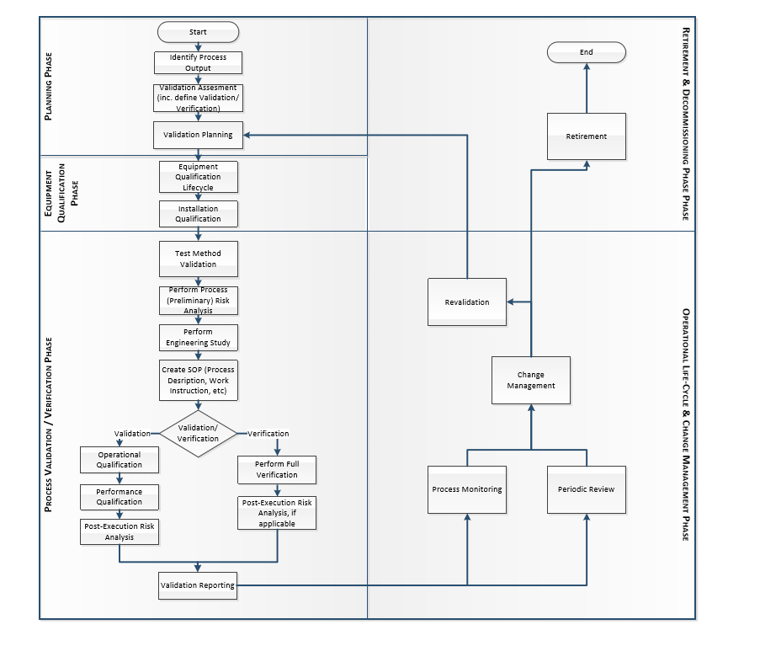

# PERIODIC VALIDATION REVIEW

A periodic review shall be held semi-annually to verify the current validation state of all the equipment at the Ethicon Endo Surgery Service and Repair Depot, Cincinnati, Ohio.

# REVALIDATION CRITERIA

Change control will establish the extent of the revalidation. The impact of the proposed change on the existing process and downstream processes shall be determined based on the nature and impact of the proposed change. Revalidation may not be as extensive as the initial validation if the situation does not require that all aspects of the original validation be repeated. Refer to Franchise Procedure for Validation (Shared) (PR-0000089) for the steps required to complete a revalidation process. Refer to WE001151 and WE001534 for reasons that might cause us to revalidate an equipment.

Revalidations shall be necessary under the following conditions. The extent of qualification activities shall be determined through a change control process:

* + - * Process changes that extend beyond the current qualified range of operation
      * Change in the process that affect product CTQ attributes.
      * Transfer of the process from one facility to another.
      * Change in the application of the process.
      * Equipment has been moved or relocated
      * Revalidations may be necessary under the following conditions. The extent of qualification activities shall be determined through a change control process:
      * Revalidation decision based on the Periodic Validation review
      * Process changes in response to a determination of negative trends in quality indicators.
      * Addition of other products to a validated process
      * Process parameters are to be changed from the initial Operational Qualification.
      * Significant modifications are made to testing equipment because of corrective maintenance activity or when parts are changed or modified.
      * Whenever significant changes are made to a product (e.g., change of raw material) occur.
      * If currently installed / used equipment is used to test a new product.
      * Validated equipment software version has changed.
      * Measurement / Test method changes (e.g. procedure, equipment, fixtures, software upgrades, etc.

# CHANGE CONTROL

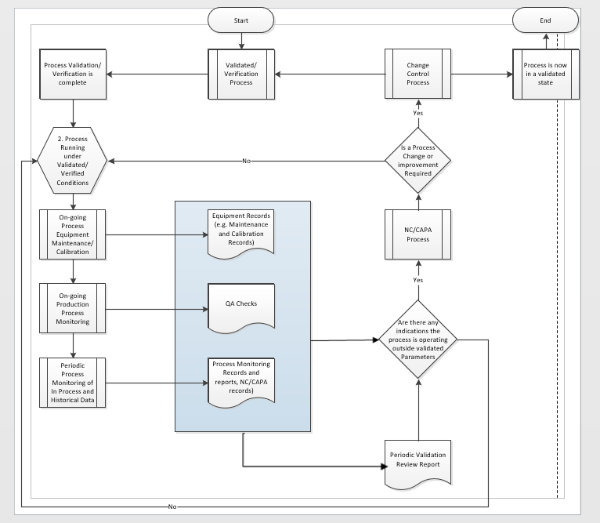

# REFERENCE DOCUMENTS

The following documents are used to develop, to support, or are referenced within this Site Validation Master Plan

Table 2 – References

| Document Number | Document Title |
| --- | --- |
| PR-0000089 | Franchise Procedure for Validation (Shared) |
| 100632816 | Franchise Process Monitoring and Control Procedure (Shared) |
| 100360960 | Franchise Form for Validation Periodic Review (Shared) |
| 100279341 | Franchise Procedure for Site Validation Master Plan (Shared) |

# ATTACHMENTS

The following are attachments to this document.

| Attachment Number | Attachment Name | Revision Number |
| --- | --- | --- |
| FB0033424 | Validation Registry or Log | A |

# 